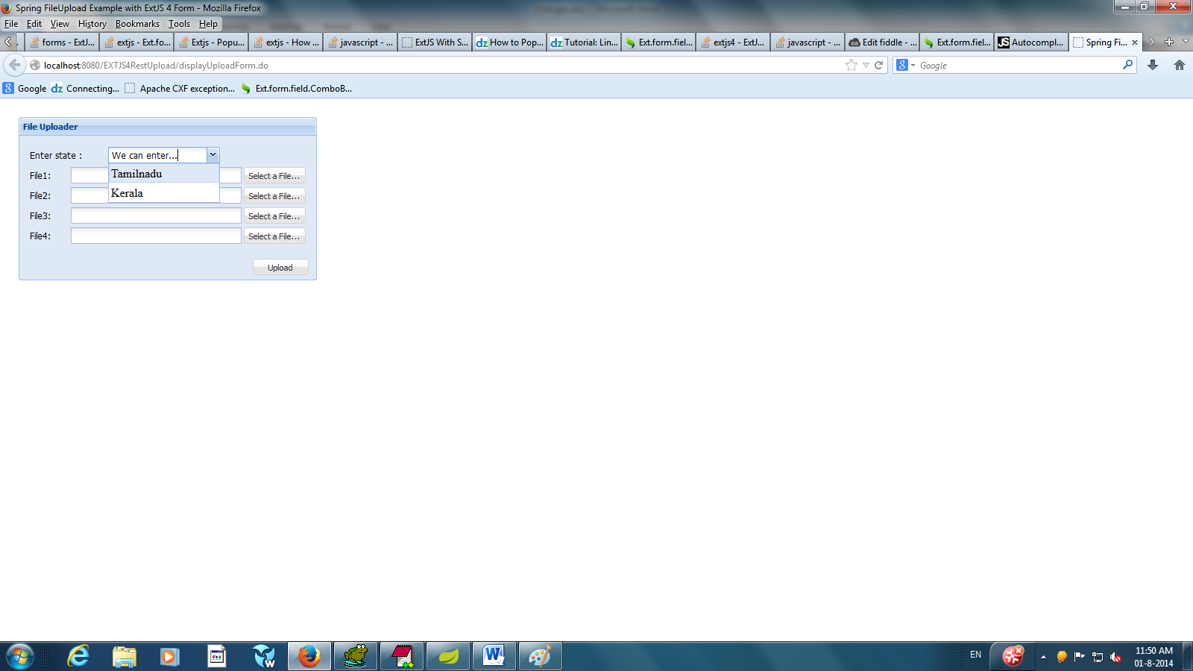Sample Ouput for the EXTJS Combobox

Following files has been modified , pls check the screens shots commented as “ The data store for EXTJS Combobox starts “ and “Code to load combobox starts ”

1. File-upload.js
2. FileUploadBean.java
3. FileUploadController.java

